Making Anthropology Matter
Vila Lanna, Prague
October 14–15, 2015

Conference Programme

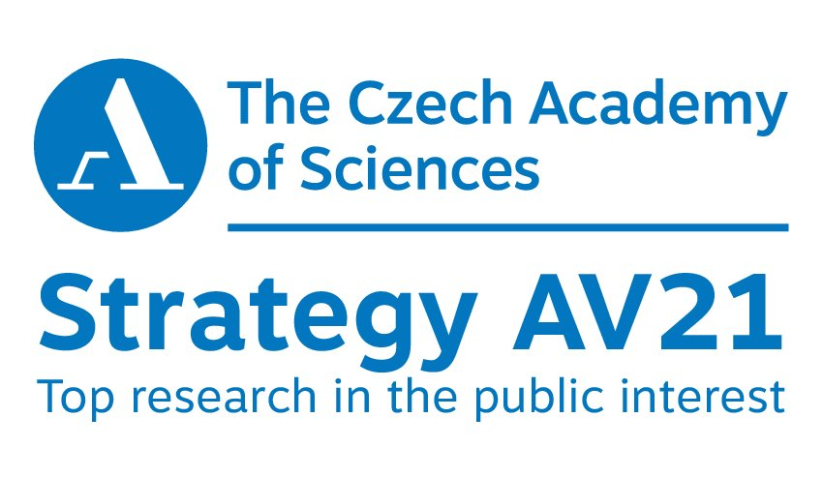
October 14 (Wednesday)

10:00 - 11:15 Opening Keynote Session

Thomas Hylland Eriksen, EASA President: Norwegian Anthropology from Success to Ambiguity
Michal Buchowski: Multiculturalism and the Fear of Muslims in a Non-Immigrant Society

11:15–12:45 Seminar - Part I

Zdenek Uherek: One anthropology or many anthropologies?

Italo Pardo: Anthropology matters

Petr Skalník: Between science and humanities: Social anthropology at the crossroads

Narmala Halstead: Making explicit: Popularisation and knowledge boundaries in anthropology

Aleksandar Boskovic: World anthropologies from a local perspective

Alexandra Bitusikova: Anthropology clustering as a way to address major societal challenges and to be heard

Tamás Régi: Some thoughts on the position of anthropology in Hungary

12:45 - 13:45 Lunch

13:45 – 15:00 Seminar - Part II

Susana de Matos Viegas: Land across borders

Valentina Grillo: Migrations and refugee issues: Shifting discourses in political anthropology

Lukasz Kaczmarek: Mobility discourse in public culture: Anthropology vs. problematic categorization of the ‘forced’ and ‘economic’ migrants

Marek Pawlak: European migration and the neoliberal imaginaries

Jaroslav Sotola and Mario Rodríguez Polo: Refugees, informal initiatives and anthropology

Judith Okely: Anthropology's contribution to Gypsy/Roma and Traveller identity and rights

15:00 – 15:15 Break

15:15 – 16:30 Seminar - Part III

Daniela Mosaad-Penickova: Medical anthropological research on migrant health in the framework of global health

Rachael Gooberman-Hill: Making anthropology matter to Europe: Contributing to decisions about health

Agnieszka Koscianska: Anthropology against sexuality and gender based discrimination

Giuliana B. Prato: From development to sustainability and social responsibility – the contribution of anthropology

Valeria Siniscalchi: Food values, economic spaces and alternatives in Europe

Monika Baer: Gender i late industrialism: The unconventional theory at the conventional research site

16:30 - 17:00 Coffee Break

17:00 - 18:00 EASA Annual General Meeting

18:00 – 19:00 Wine Reception

October 15 (Thursday)

9:00 - 11:00 Seminar - Part IV

Shukti Chaudhuri-Brill: Making culture count

Daniel Sosna: Are anthropologists persuasive?

Georgeta Stoica: Find a job – find anthropologists

Brenda Beck: Repurposing stories to teach about social justice

Haldis Haukanes: Towards an engaged anthropology of/for the future?

Auksole Cepaitiene: Emphasising education in the development of anthropology

Paolo Favero: Interdisciplinarity Indiscipline”: an anthropologist in the world of images

Agnieszka Pasieka: Anthropology and the ability to listen

Hana Cervinkova: Seeing the Invisible Other – Anthropology and Teacher Training in Central Europe

11: 00 – 13:00 Working Session and Lunch

13:00 – 14:00 Press Conference

14:30 – 16:30 Capacity Building Workshop led by Niko Besnier and Susana Narotzky

